EVENT DESCRIPTION
http://londonshortseries.com/

The annual IMDB listed London Short Series Festival is an International celebration of online storytelling with a British founding. Watch the inspiring and creative short-form series on a big screen to experience the magic and friendly atmosphere of our film festival located in the heart of London.

Part of a worldwide network of festivals ,London Short Series is an opportunity for web series and digital content makers to unite for three days to celebrate online storytelling. The festival provides digital story-makers with a unique opportunity to showcase and partake in original screenings, workshops from leading industry professionals and more, as an international audience of digital movers and shakers unite for this unique occasion.

“London Short Series is a feast for anyone addicted to short-form storytelling, a feel-good, friendly film festival that will both delight and inspire you” Brian Luff (Former BBC Comedy Senior Digital Producer).

AWARDS & PRIZES
Best Drama/Thriller/Mystery
Best Comedy
Best Documentary
Best LGBTQ
Best Screenplay for Web/TV series
Best Sci-fi/Horror/Fantasy
Best Animation
Best Short film
Best Student film
Best Music Video
Best Virtual Reality (VR)
Best Series
Best Actor
Best Actress
Best Directing
Best Editing
Best Production Design
Best Cinematography
Best Ensemble (Series)
Spirit of the Festival Award
French Touch Award
British Vibe Award

RULES & TERMS
All series, short films, music videos and short scripts (screenplays) are eligible to submit. You production must be 2016 or later .

Submissions for series must have at least TWO (2) produced online episodes or a Pilot episode available to view at time of entry.

Episodes cannot exceed 15 minutes in length. Series with individual episodes exceeding 15 minutes in length are welcome to submit a shortened version(s) of an episode(s) for the purpose of entering into the festival. Series with short episodes (5 minutes or less) that are accepted into the Official Selection will be allowed to screen two episodes.

Short films must be maximum of 15mins in length.

Please choose the genre that best represents your work even if your work can be classified under more than one category. No duplicate submissions under a different category.

Each submission MUST have a list of credits, short synopsis describing the series or films, a poster and optionally production stills.

Employees or agents of London Short Series Festival and their immediate families are ineligible to receive any awards.

Entries that are not in English must have English subtitles.

Judges panel use a selection system created to provide fair measurements.

All entries, including international submissions, are eligible for prize awards in each category. We strongly encourage all finalists to attend the festival.

Foreign submissions will be judged with the same criteria as national submissions.

Participation

Content submitter must be 18 years of age or older.

Submissions must be the intellectual property of the submitter, and/or their team. No proxy submissions.

Payment / Submission

Entry fees are non-refundable.

Applicant can submit more than one project to the festival. Each submission requires an entry fee.

All entries must be submitted online through our submission application.

Other

By submitting to London Short Series Festival, you confirm that you hold the rights to (or are authorised to use) any and all audio and video in your work. London Short Series Festival will not be held responsible for any claims stemming from the failure of the creator/submitter to properly obtain the rights to material submit and/or screened.

All Decisions made by London Short Series Festival are final.

By participating in the London Short Series Festival, each participant agrees to hold London Short Series Festival and its employees, directors and representatives harmless from any and all losses, damages, rights, claims and actions of any kind in connection with the event or resulting from acceptance, possession or use of any prize.

You grant London Short Series Festival the right to use the name, logo and content of your web series and films for awards presentations, highlight reels and promotional material.

London Short Series Festival reserves the right to amend guidelines, selection criteria, awards, screening, and activities if necessary.

_________________________________________________________________________________
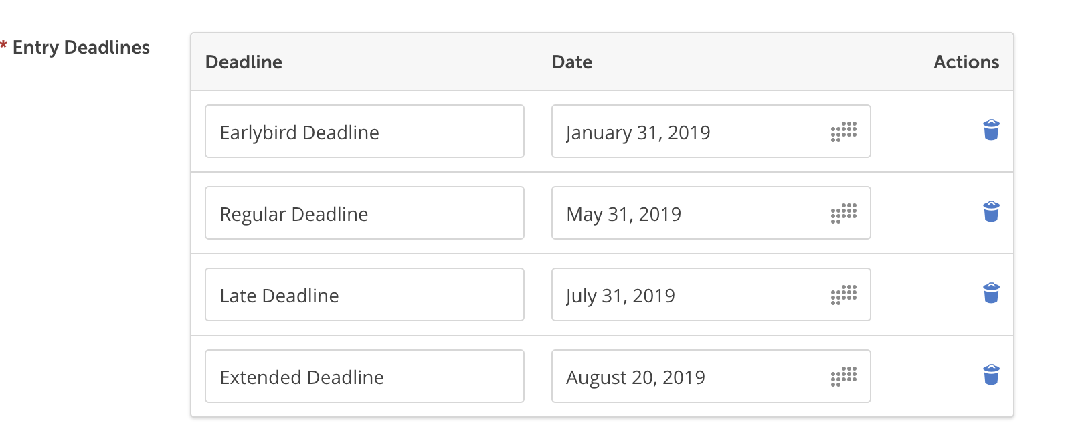

CATEGORIES &ENTRY FEES
SERIES
Early €40
Standard €50
Late €70
Extended €80

SHORT FILMS & MUSIC VIDEOS
Early €20
Standard €25
Late €40
Extended €70

SCRIPTS (We accept completed scripts and screenplays for Web series, TV series and short films ONLY which have not been produced yet. These can be scripts/screenplays in developments also.)
Early €20
Standard €25
Late €40
Extended €70

STUDENT SHORT FILMS, MUSIC VIDEOS & SERIES (Documentation and proof will be required for this category)
Early €20
Standard €25
Late €40
Extended €70

