CLICK FOR FESTIVALS submission site

WATCHDOG FILM FESTIVAL

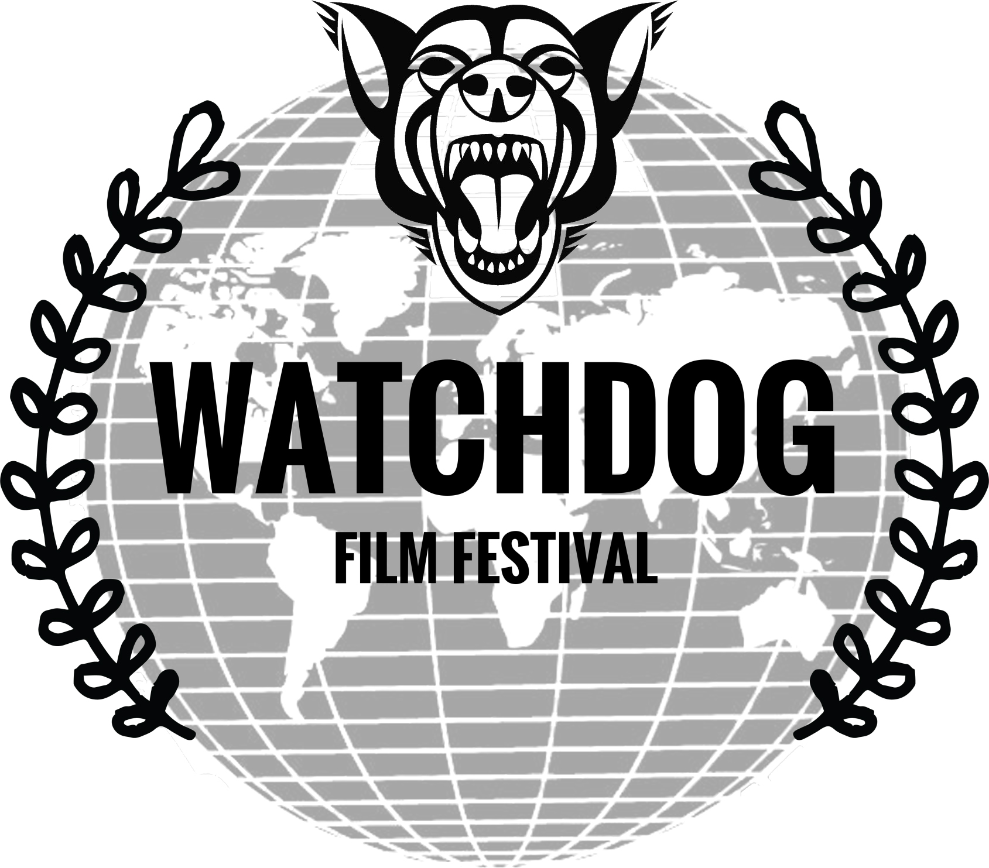

- Rules and regulations.
The Watchdog Film Festival is all about celebrating quality film-making on topics of social and societal importance.
This festival accepts submissions from all over the world with a particular focus on investigative documentaries, exposés, journalism-related fiction films, and films that make the viewer question the traditions, practices, systems, and hierarchies within the contemporary world.
The festival event will be held in Brisbane, Australia and will screen around 40-80 films including smartphone films, documentaries, fiction films, student films, charity (not-for-profit company) made films, and corporation made films.
Filmmakers will have a great opportunity to network with industry professionals at this event and see some of the best investigations done in 2017 by filmmakers around the world.
Tickets will be available at Eventbrite from December 2017 and will be free for those who submit films, their cast and crew, and media professionals.
FILMMAKERS:
We are the first and only film festival that will screen investigative films that dive into worlds otherwise unknown. We will shortlist films that cover matters of social importance and public significance and that ask us to question our own individual world or our systems within society. These can be documentaries, fictional films, narratives, journalism-style segments, and so on, as long as the film has an important message for society, be well researched, and based on fact. For example, the movie Okja explains the complexity of the meat industry to viewers in a very skilled, entertaining and tactful way drawing parallels to all of the meat industry including the dog meat trade. Okja is explaining our corporate meat culture back to itself and thus is a "watchdog" style fiction film. Another great example is Blood Diamond (film) and Blood Diamonds (documentary) which both explain the consequences of the real diamond trade in parts of Africa. These movies expose socio-political and economic systems so viewers can question the diamond industry and whether they want to support it.
Other examples of films with a watchdog message using a watchdog style are.....
Fiction:
Crash
V for Vendetta
Nightcrawler
Click
Pay It Forward
Happy Feet
The Big Short
Dear White People
Shattered Glass
War Dogs
Documentaries:
Food, Inc.
Bowling for Columbine
Super Size Me
Who Killed the Electric Car?
Inside Job
Citizenfour
The Story of Aaron Swartz, The Man Who Could Change the World
Even though the above films have a high budget, we are happy to accept no or low budget films especially those financed via crowdfunding.
The program for this festival will be announced early 2018 and we seek to screen several investigative exposés, several smartphone made films, a few feature length films, and several short films.
Attendance at the event will be free for cast and crew of submitted films and winners will be featured on our Facebook page, on our website, and on twitter.
Anyone attending this film festival will learn a lot from the content of the screened films as well as network with other filmmakers and industry professionals. Prizes will be awarded on the night and shortlisted nominees will be contacted early 2018.
This will be a great event!

Awards & Prizes
As this event is in its first year, we greatly appreciate those submitting films. We endeavour to have corporate sponsors who offer monetary prizes, equipment and/or meetings with relevant industry professionals to take your project to the next level.
Total prize value to be updated.

Rules & Terms
All films must be submitted via an online screener for review.
Films will be shortlisted and submitters will be contacted prior to the event.
We accept films from all over the world and encourage all budget levels to submit.

- Information about deadlines and fees.
Dates & Deadlines

October 31, 2017 Earlybird Deadline

November 22, 2017 Regular Deadline

December 14, 2017 Late Deadline

January 4, 2018 Extended Deadline

January 29, 2018 Notification Date

February 24, 2018 Event Date

Categories & Fees
- Student Film
All styles and genres with an important message or investigative framework made predominantly by students as part of a university, TAFE, or educational course. You will be required to show evidence of student membership.
Earlybird Deadline October 31, Standard Fee: $5 USD
Regular Deadline November 22, Standard Fee: $10 USD
Late Deadline December 14, Standard Fee: $20 USD
Extended Deadline January 4, Standard Fee: $40 USD
- Short Film
All styles and genres with an important message or investigative framework.
Earlybird Deadline October 31, Standard Fee: $13 USD
Regular Deadline November 22, Standard Fee: $22 USD
Late Deadline December 14, Standard Fee: $30 USD
Extended Deadline January 4, Standard Fee: $50 USD
- Mid-length Film
All styles and genres with an important message or investigative framework. Over 10 minutes but under 29.
Earlybird Deadline October 31, Standard Fee: $15 USD
Regular Deadline November 22, Standard Fee: $25 USD
Late Deadline December 14, Standard Fee: $37 USD
Extended Deadline January 4, Standard Fee: $50 USD

- Feature Film
All styles and genres with an important message or investigative framework. Over 29 minutes but under 46 minutes please. If you have a compelling feature that is longer please submit it but contact us after as it would need to be cut shorter for screening.
Earlybird Deadline October 31, Standard Fee: $25 USD
Regular Deadline November 22, Standard Fee: $35 USD
Late Deadline December 14, Standard Fee: $50 USD
Extended Deadline January 4, Standard Fee: $70 USD
- Smartphone (cell phone) film
We invite the average citizen to transform their smartphone clip into a short film and submit it to the Watchdog Film Festival. At least 80 percent of the film must be filmed using a smartphone device. External tools, such as a microphone or smoove, can be used. Editing can be done on a computer.
Earlybird Deadline October 31, Standard Fee: $10 USD
Regular Deadline November 22, Standard Fee: $20 USD
Late Deadline December 14, Standard Fee: $30 USD
Extended Deadline January 4, Standard Fee: $40 USD
- Investigative exposé
All styles and genres with an investigative framework. This might include covert videography, undercover camera operation, surveillance footage, investigative journalism, fact finding/checking via hard-to-get interviews, examining and verifying facts, and so on.
Earlybird Deadline October 31, Standard Fee: $1 USD
Regular Deadline November 22, Standard Fee: $15USD
Late Deadline December 14, Standard Fee: $25USD
Extended Deadline January 4, Standard Fee: $40 USD

- Charity-film (self made)
All styles and genres with an important message or investigative framework. MUST BE produced and filmed by a registered charity in the country of origin and show their logo before and after the film. You will need to provide your charities details, which we will verify otherwise you will be disqualified.
Earlybird Deadline October 31, Standard Fee: $1 USD
Regular Deadline November 22, Standard Fee: $15USD
Late Deadline December 14, Standard Fee: $25USD
Extended Deadline January 4, Standard Fee: $50 USD
- Corporate and social responsibility film
All styles and genres of a corporate made film that celebrates businesses that are giving back to their community.
Earlybird Deadline October 31, Standard Fee: $50 USD
Regular Deadline November 22, Standard Fee: $85USD
Late Deadline December 14, Standard Fee: $115USD
Extended Deadline January 4, Standard Fee: $160 USD
- Photography (stills)
Photo essays composed of no more than 5 photos that transmit an important message. Investigative frameworks are preferred.
Earlybird Deadline October 31, Standard Fee: $10 USD
Regular Deadline November 22, Standard Fee: $20 USD
Late Deadline December 14, Standard Fee: $30 USD
Extended Deadline January 4, Standard Fee: $40 USD
- Brisbane locals
This section is for submissions from Brisbane, Gold Coast, and Sunshine Coast locals ONLY who will be in attendance at the event. The film should be shot in Brisbane and its hinterland to qualify for this section and award. Evidence of residence and student status will be requested.
Earlybird Deadline October 31, Standard Fee: $1 USD
Regular Deadline November 22, Standard Fee: $10 USD
Late Deadline December 14, Standard Fee: $15USD
Extended Deadline January 4, Standard Fee: $30 USD

Festival Rationale

Each section of the film festival has its own rationale and will be addressed separately.

Brisbane local films:
- Brisbanites who are informed citizens wanting to submit or view films that are of public significance.

Journalists and mass media:
- Journalists (or aspiring journalists) wanting to screen their investigative exposé – an area often overlooked by both documentary and film markets.

Domestic and international students:
- Student filmmakers – many films made by students are fiction and are rarely screened beyond their class. I want to celebrate and reward quality films by students that explore important social topics. After all, many talented young filmmakers move from Brisbane to Sydney or Melbourne stating that there are no opportunities for local filmmakers. We need to change that and it starts with this festival (and others in South East QLD), which celebrate their work.

Citizen or witness filmmakers:
- We also aim to highlight the importance of witness and citizen filmmaking. We often see short clips on social media that people have filmed using their mobile phones. They have an eye-witness account of events and provide a first-person-view (FPV). Most of these videos go online without context and nothing usually eventuates aside from online discussions. With a little tweaking, interviews, fact checking, and narration, some of these clips can be transformed into powerful documentaries. Think films of racist tirades on a train transformed into a short documentary on racism versus inclusivity (eg., https://youtu.be/ZBdYvN49eRU?t=122) (https://youtu.be/Dkm9CWiphWU?t=129) and moving into inclusive multiculturalism. These smartphone films should have an important message or investigative framework but most don’t. We invite the average citizen to transform their smartphone clip into a short film and submit it to the Watchdog Film Festival.

Charities or not-for-profit NGOs:
- Charities that want some recognition and exposure for the work they do, hence we have included a separate section and award for film submissions by registered charities.

The responsible businesses:
- Corporations who give back to the community with the aim of having a socially responsible business. The contributions and impacts these corporations have on the local community should be celebrated and recognised publicly at our festival via a screening and award category. I hope that this style of accolade will eventually encourage future local Brisbane businesses to make an effort to give back to the community.

Raising Brisbane’s international profile:
- The international community. Brisbane is not well known overseas and, one international event at a time, we are helping to change this. I want Brisbane to become known for watchdog-style films and being a forward, progressive, and inclusive society which all starts with the public becoming aware of the issues we face and collectively working toward overcoming those issues. I aim to have a secondary screening of this festival in South Korea and in the U.S. in consecutive years.

Event info

We hope to screen around 20-40 films at Griffith University February 23 or 24 that did not make the final screening but encompass the Watchdog theme of the festival or celebrate Brisbane as a progressive community. This would coincide with orientation week (party week) for new university students and consequently be a great opportunity to establish brand presence when young people are most receptive to opening their minds to new concepts, businesses, and brands.

On February 24 we hope to screen a further 20 to 40 films (depending upon time and the length of the shortlisted films) on the première night, followed by an awards ceremony.

The awards categories, which may change, are as follows:

STUDENT FILMS:
Best student film
Rising star student film
Best international student film

SHORT FILMS:
Best short film
Best short investigative documentary

MID-LENGTH FILM:
Best mid-length film

FEATURES:
Best feature film
Best investigative documentary

SMARTPHONE FILM:
Best smartphone film

CHARITY FILM:
Best charity film
Social justice award

Corporate and social responsibility:
All corporations screened at the festival will receive an accolade - Socially responsible corporation award.

PHOTOGRAPHY COMPETITION (STILLS):
The social justice photographer award
Best of the festival
Most courageous photograph*

FESTIVAL WIDE AWARDS (any category can receive):
Best of the festival
Best investigative exposé
Watchdog spirit award*
Most courageous film*
Most inspirational film*
Best social justice message*

*This award will be determined by festival organisers

