Agreementertification of Entry
- I certify that I own the film I am submitting to BAICFF (aka, “the Festival”). I acknowledge that I have the sole and exclusive ownership of all rights and have the full authority to submit this film to the Festival or I am duly authorized to submit this film.
- This film is not subject to any litigation nor is threatened by any litigation.
- I will indemnify, defend and hold harmless BAICFF, its organizers and sponsors, individually
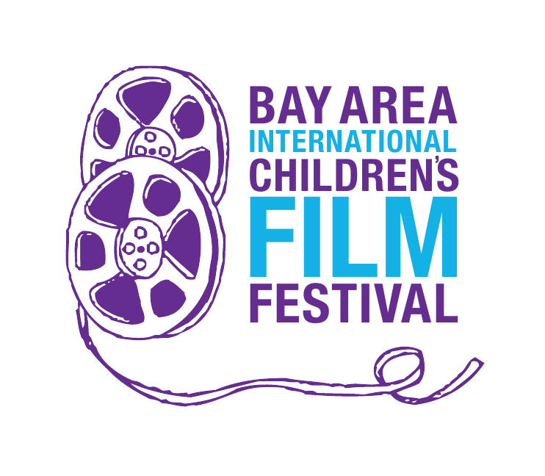
and collectively, from and against all claims, complaints, causes of action, liabilities, judgments, losses, costs and expenses including reasonable attorneys fees arising out of or in connection with any and all claims and/or third party claims based on materials I am submitting to the Festival.
- I understand that the organizers of the Festival cannot be held responsible for the accidental damage or loss of any material submitted. Utmost care will be taken with each and every film, but in the event of damage or loss, BAICFF, its organizers and sponsors cannot be held liable.
- I authorize BAICFF to present excerpts of up to 30 seconds from my film for publicity purposes and/or publish material provided for publicity purposes.
- To the best of my knowledge, all of the statements in this document are true.

