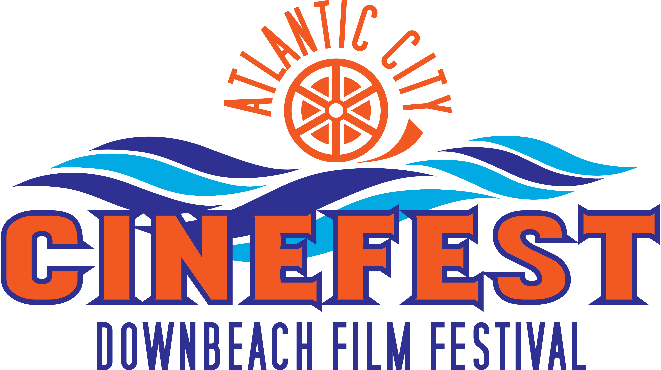

A 501(c)(3) New Jersey non-profit

FILM SUBMISSION
Official 2014 Entry Form
www.downbeachfilmfestival.org

Please fill out form and send it with two copies of the film on DVD to:

Downbeach Film Festival/Atlantic City Cinefest
405 Berkshire Drive
Ventnor, NJ 08406

Filmmaker Information:
Name: ______________________________________________________________________
Address: ______________________________________________________________________
City, Zip, State:
______________________________________________________________________
Phone: E-mail:
____________________________ _________________________________________
Website: ______________________________________________________________________

Film Information
Category
__ Feature (more than 60 minutes)
__ Documentary
__ Short (less than 60 minutes)
__ One-minute film

Title of Film: Running Time:
______________________________________ ____________

Brief Synopsis:
________________________________________________________________________________________________________________________________________________________________________________________________________________________________________________________________________________________

How did you find out about the festival? ______________________________________________________________________

Where else has the film screened:
________________________________ ___________________________________

ENTRY FEES:
Early Deadline: May 1
One-minute film: $10
Short film under 60 minutes: $15
Feature Film or Documentary over 60 minutes: $25
Student film: $10

Regular Deadline: June 30
One-minute film: $15
Short film under 60 minutes: $25
Feature Film or Documentary over 60 minutes: $35
Student film: $14

Late Deadline: August 15
One-minute film: $20
Short film under 60 minutes: $30
Feature Film or Documentary over 60 minutes: $45
Student film: $18

Send a check/money order payable to the Downbeach Film Festival

Rules
• Judges will select up to 25 winners for the one-minute film to be shown in the One Minute Film Festival during the festival in October.
• Entry fees will not be returned.
• Downbeach Film Festival reserves the right to impose a $20 surcharge for returned checks.
• Filmmaker agrees that he/she will be solely responsible for the delivery of his/her film materials to and from the festival venue.
• Entry title and name of entrant must be on all materials.
• Photographs and press kit will be needed if a film is accepted.
• I agree :
1. to the best of my knowledge, all of the statements in this document are true;
2. this film is not subject to litigation nor is threatened by any litigation;
3. I am duly authorized to submit this film to the Downbeach Film Festival;
4. to hold the Downbeach Film Festival harmless from damage to or loss of the DVD;
5. to hold the venue harmless from damage to or loss of the DVD;
6. to certify that I hold all necessary rights for this submission;
7. if chosen, I give Downbeach Film Festival permission to stream portions of my video on the official website, and use clips on a promotional trailer;
8. if chosen I give Downbeach Film Festival the right to include my film in accompanying promotional literature. I realize that the festival will not compensate me financially.

Filmmaker signature: Date:

