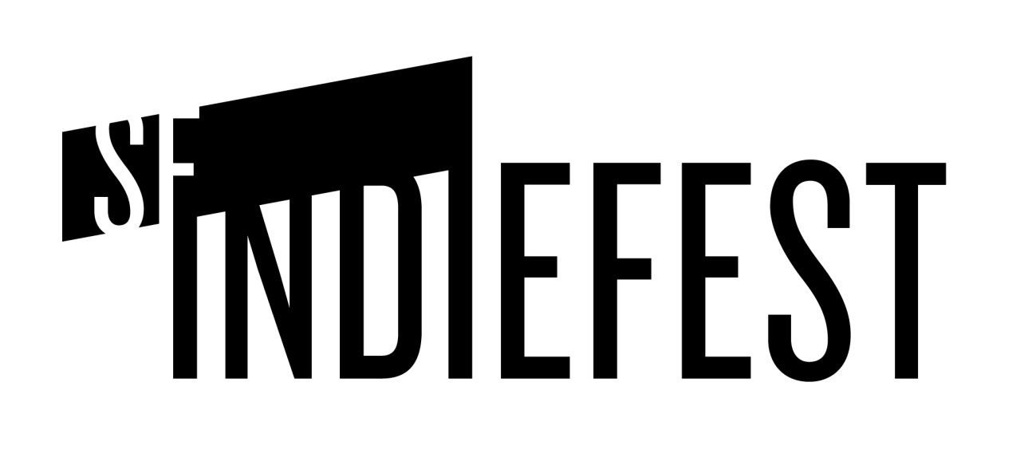

SF Indiefest is a year-round, non-profit organization that has been operating since 1998. We present three annual festivals: the SF Independent Film Festival (SF Indie for short), the SF Documentary Festival (DocFest for short) and Another Hole in the Head, our genre film festival. In 2012 we also premiered the Northern California Action Sports Film Festival and the US edition of the touring shnit International Short Film Festival.
Last year over 21,000 film and event goers attended SF Indiefest events. We are a 501c3 non-profit with support from San Francisco Grants for the Arts, the San Francisco Art Commission, and many local newspapers, radio stations, websites, breweries, hotels, venues, businesses, and arts lovers like you!
All films less than 18 months old are eligible to submit:
Features: 45 minutes or longer
Short films: Up to 45 minutes

