
Short film contest
Rules and Regulations

1. “Il Circo dell’Arte” Cultural Association, based in Venosa (PZ), Italy in Piazza Q. Orazio Flacco n. 24, in collaboration with Artistica Management (www.artisticamanagement.com), announces the 3rd edition of the international short film contest Five Continents Film Festival, as part of the 12th edition of the Five Continents Festival (www.cinquecontinentifestival.com).

2. The Five Continents Festival is, in its nature, a place for diverse cultures and people to meet, where comparison is stimulated, diversity is praised, dialogue is preferred, awareness is promoted, multiculturalism is celebrated. Through short films, the Five Continents Film Festival offers to share with the public traditions and customs of people from all over the world and their cultural expressions.

3. The Five Continents Film Festival will consist of multiple film screenings and will take place at different times and locations from June to September 2016. It will conclude with a final event, scheduled in mid-October 2016, which will include a screening of the short film finalists and announcement of the winning short film, chosen according to the final judgment of a committee of experts and professionals. The calendar and times of screenings will be published on our website and on the Five Continents Festival program.

4. The director of the winning short film will be awarded the festival prize, that is a plexiglass sculpture created by the artist Carlo Massimo Franchi. Other prizes and special awards could be assigned to particularly deserving short films, directors, producers, actors, scriptwriters, score composers, etc.

5. Participation in the Five Continents Film Festival is free of charge and is open to all short films, regardless of genre, style, budget or language.

6. Submitted short films must have been completed after January 1st, 2012 and have a duration of between 3 and 20 minutes, opening and closing credits included. Films previously submitted or awarded in other contests are admitted. Films in a foreign language must have Italian subtitles.

7. Short films must be submitted within and not beyond May 31st, 2016, using one of the following ways:

- Vimeo (send private link with password to submit@cinquecontinentifilm.com);
- Dropbox, Google Drive, OneDrive, Copy, etc. (send link to submit@cinquecontinentifilm.com);
- WeTransfer (send file to submit@cinquecontinentifilm.com);
- affiliated submission platforms (Click for festivals, FilmFreeway, Festhome, FilmFestivalLife).

8. At the same time please fully complete and sign the official application form and send it either by post at Associazione Culturale “Il Circo dell’Arte”, Piazza Q. Orazio Flacco, 24 - 85029 Venosa (PZ) - Italy or by e-mail to submit@cinquecontinentifilm.com, attaching the film’s official poster as a pdf or jpeg. The application form is not required in case of submission through affiliated submission platforms.

9. The Organization will select at least 20 short films, which will be screened on multiple occasions in different locations between June and September 2016. An audience jury will select the winner of each stage.

10. The final list of finalist short films will be composed of the winners of audience selections and other short films chosen directly by a committee of experts and professionals.

11. Each participant of the Five Continents Film Festival declares ownership of the presented film’s legal rights and says film does not contain any defamatory content nor violates any law. Each participant relieves the Organization from any responsibility for the film’s content or for eventual claims for compensation on the part of individuals filmed without authorization or consent.

12. Upon registration, each participant of the Five Continents Film Festival authorizes the Organization to publicly screen his/her film and grants reproduction rights for all activities associated with the organization, publicity and communication of the Five Continents Film Festival. Films for publicity campaigns that are not directly associated with the film festival or other related activities are excluded.

13. Upon registration, each participant of the Five Continents Film Festival authorizes, in compliance with Italian Legislative Decree 196/03, “Il Circo dell’Arte” Cultural Association to use personal information for activities related to the Five Continents Film Festival and connected events.

14. The Organization reserves the right to make any modifications to these Rules and Regulations to improve the success of the Five Continents Film Festival.

15. All communication directed to the Five Continents Film Festival can be sent to the following: info@cinquecontinentifilm.com, tel. + 39 097236198, mobile +39 3398357918, Associazione Culturale “Il Circo dell’Arte”, Piazza Q. Orazio Flacco, 24 - 85029 Venosa (PZ) - Italy.

16. Subscription and presentation of the application form imply a complete, unconditional acknowledgement and acceptance of the Rules and Regulations.

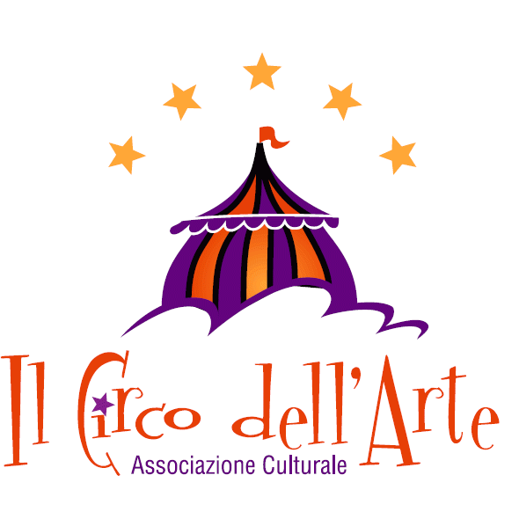
Management and coordination
Associazione Culturale “Il Circo dell’Arte”
Piazza Q. Orazio Flacco, 24 - 85029 Venosa (PZ) - Italy
Tel. e Fax +39 097236198 - Mobile +39 3939762387 - +39 3398357918
info@cinquecontinentifilm.com - pec: ilcirco@arubapec.it
www.cinquecontinentifilm.com
Application form

Film information
Title: __________________________________________________________________________
Year: __________________________________________________________________________
Country: __________________________________________________________________________
Language: __________________________________________________________________________
Subtitles: __________________________________________________________________________
Duration: __________________________________________________________________________
Aspect ratio: __________________________________________________________________________
Director: __________________________________________________________________________
Writer: __________________________________________________________________________
Screenplay: __________________________________________________________________________
Production: __________________________________________________________________________
Cast: __________________________________________________________________________
Unpublished work (mark with an X) __________________ First work (mark with an X) _________________
Synopsis: _______________________________________________________________________________
_______________________________________________________________________________________
_______________________________________________________________________________________
_______________________________________________________________________________________
Participation in other festivals: ______________________________________________________________
_______________________________________________________________________________________
_______________________________________________________________________________________
_______________________________________________________________________________________
_______________________________________________________________________________________
Awards: ________________________________________________________________________________
_______________________________________________________________________________________
_______________________________________________________________________________________
_______________________________________________________________________________________
_______________________________________________________________________________________
Director’s biographical notes: ______________________________________________________________
_______________________________________________________________________________________
_______________________________________________________________________________________
_______________________________________________________________________________________
_______________________________________________________________________________________

Personal information
First name: __________________________________________________________________________
Surname: __________________________________________________________________________
Birthplace: __________________________________________________________________________
Date of birth: __________________________________________________________________________
Nationality: __________________________________________________________________________
Address: __________________________________________________________________________
Postal code: __________________________________________________________________________
City: __________________________________________________________________________
Telephone: __________________________________________________________________________
E-mail: __________________________________________________________________________

The undersigned

- declares ownership of the presented film’s legal rights;
- declares the film does not contain any defamatory material or any material that violates any laws in force.
- declares to have read and accepted the official Rules and Regulation of the competition;
- authorizes free public screening of the film;
- authorizes the use and processing of personal details also for informational purposes in compliance with Italian Legislative Decree 196/03.

Place and date: _______________________________ Signature: __________________________

NB: Once completed and signed, this application form must be sent to the Organization by and no later than May 31st, 2016 by post (the date on the postage stamp will attest) or by e-mail (scan the form and send it as a pdf or jpeg). Incomplete application forms and forms with inaccurate information or without a signature will not be taken into consideration. The official flyer of the film must be attached to the application form as a pdf or jpeg.

