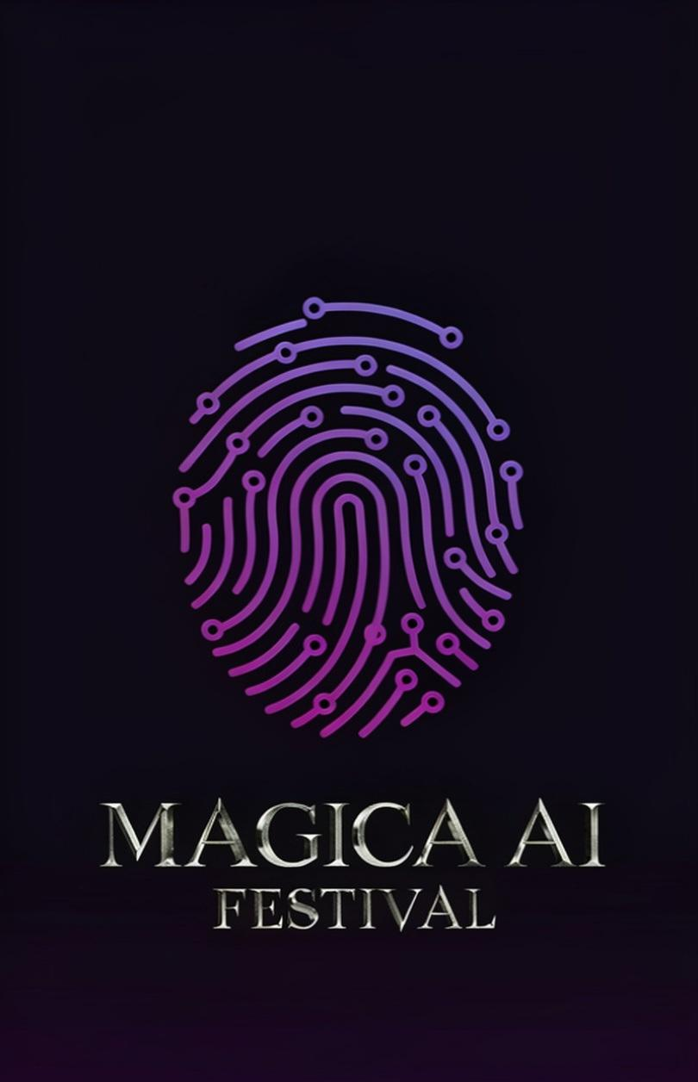

"Introducing Magica AI Festival”

Where human vision meets artificial intelligence.

Magica AI Festival is a global festival dedicated to AI-assisted film, animation, advertising, and new media. We showcase short films, features, animation, commercials, TV pilots, web series, trailers, music videos, and AI art videos that prove one thing: **technology elevates storytellers — it doesn’t replace them.

Our Philosophy
AI is a tool to assist the storyteller, not replace them. The idea, vision, and voice must remain human. We champion creators who use AI in service of their highest creative good, their communities, and cultural truth. AI should serve us, not manipulate us. This is the standard we celebrate.

Founder’s Statement
“I believe AI should be a tool that serves creativity and community. This festival is here to support artists — to give them a safe space to create, share their work, and be protected. That’s why we partner with law firms to guard against harm and social abuse. And it’s why we champion documentaries and films that tell the cultural truth. AI should serve us. Not manipulate us. That’s the standard we’re setting.” — Lady Maggie Magica

That’s why we partner with law firms to guard against harm and social abuse. And it’s why we champion documentaries and films that tell the cultural truth.
AI should serve us. Not manipulate us. That’s the standard we’re setting."

Our History
Launched two years ago with WICA Los Angeles, La Femme Independent Film Festival, and Magica Advertising. Magica AI has featured projects that went on to win international awards. We’ve presented at La Femme and Magica House events at the British Parliament, House of Lords, UK, and in *Mag-Magazine* Cannes Edition 2026.

What We’re Doing Now
Magica AI Festival is now a standalone global event. We collaborate with creative professionals and AI experts worldwide, and partner with a European law firm to promote responsible AI use, defamation protection, and safeguards against digital abuse. We also work with historians and archival libraries to ensure historical accuracy and preserve cultural heritage in AI-generated work.

Festival Awards

- Best Short Film
- Best Feature Film
- Best Advertisement
- Best Documentary
- Best Trailer
- Best Music Video
- Best AI Painting/Art Video
- Magica AI Social Awareness Award
- Audience Award

---

Submission Rules & Requirements

Accepted Formats
Short films, feature films, animation, commercials, TV pilots, web series, trailers, music videos, and AI painting/art videos.

AI Usage Policy
Projects may use AI for any portion of the work — from 1% to 100%. All submissions must include a brief statement disclosing how AI was used in your creative process. We judge the story, craft, and human vision, not the percentage of AI.

Duration Requirements
- Short films: 20 minutes or less
- Feature films: 40 minutes or more
- Trailers, commercials, music videos: 5 minutes or less

Eligibility & Legal Requirements
1. Projects must be original with a strong concept and human creative lead. AI may be used for any part of the project. Disclosure of AI use is required.
2. All IP — including idea, script, music, footage, and AI-generated elements — must be legally owned or licensed by the submitting creator.
3. If your work features a real person, likeness, synthetic recreation of a real person, or brand, you must provide written authorization. Unlicensed use will be declined.
4. Documentaries or projects with historical content must present verified, accurate information. Include your source or historian verification. We do not promote misinformation.
5. All music and songs must be properly licensed with approval from the composer, producer, or rights holder.
6. Submissions open worldwide. No age or nationality restrictions. Student films welcome.
7. **You own your work.** Submitting does not grant Magica AI Festival rights to train AI models on your project.

Screening & Festival Participation
8. By submitting, you agree to our Code of Conduct. We maintain a respectful environment. Harassment, racism, or misconduct will result in disqualification and may result in legal action.
9. If selected, you must provide all required technical materials and respond to festival communications promptly. Non-response will result in removal from the program.
10. Selected creators grant Magica AI Festival non-exclusive rights to use posters, trailers, and stills for festival promotion.
11. Selected films will screen at live venue events in London, Paris, Los Angeles, and India, and online via Magica Cinémathèque — our secure platform for ticketed audiences only. Current reach: nearly 1M viewers.

Partnership Opportunities
We welcome brands, studios, and tech partners to join us. Partners can participate in our conference and Magica Villa event during the Cannes Film Festival, reaching 10M+ filmmakers and investors worldwide.

Submission is open 30 june till 1st of august 2026, the selected projects for this edition will be screened at magica cinematheque for the festival audience only.

Event date from the 2nd of augustus till 5th of august 2026

Fees Free till 20th of july 2026
From 21st of july till the closing submission fess 5 £

