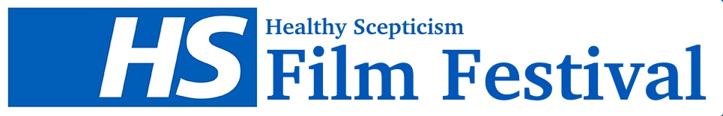

THE HEALTHY SCEPTICISM SHORT FILM COMPETITION
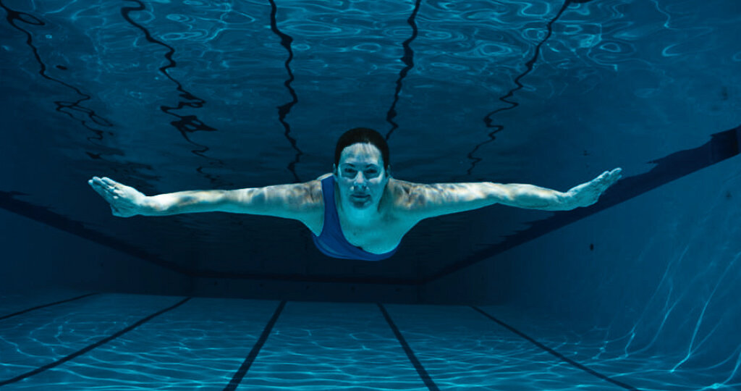
We invite submissions of short films (under 15 minutes) to appear as part of the Healthy Scepticism film festival. Submissions should offer some contemplation of the issues under consideration at the Healthy Scepticism project (outlined below), and may do so in any the filmmaker sees fit. Submissions might explore, for example, the following kinds of questions: What are your or others’ experiences of health, illness, wellness, medicine, healthcare? What is your perspective on how our healthcare systems do and do not work? How do we currently think of ourselves as “ill” or “healthy,” and why? What role does media – including social media – have in our perceptions of health, wellness, illness and disease? How do personal encounters, family histories, ethnic, sexual and gender identities change our experiences of health and illness, of healthcare and healthcare systems? How has COVID-19 changed things for us in terms of how we understand health and its care?
©helmiestil
We will feature the films of our finalists as part of our virtual film festival, and one overall winner will get a £250 prize, and will be featured in the festival alongside an interview with the winning filmmaker. The winner will be chosen by an interdisciplinary panel of judges working across the content areas of the Healthy Scepticism project.

THE Healthy Scepticism PROJECT
Health sceptics have never been more in the news. Though mask-abstainers and COVID-19 conspiracy theorists filled our headlines early on, they have more recently had to share with new and more measured conversations around vaccine hesitancy and the very real fears, experiences and collective memories that drive it. These are not new feelings. Sometimes these scepticisms are the result of the ways in which healthcare has let us down now and in the past; other times, they are the result of unique, personal and specific experiences. Scepticism arises both within and outside the formal contours of medical practice. It differs from community to community, individual to individual and nation to nation. Scepticism can be transient or specific to single issues or perhaps revolve around other, more culturally embedded networks of caring and healing that trump in importance healthcare’s more formalised versions. Wherever these are and however they appear, the Healthy Scepticism aims to trace them: to explore what the history and present of medical scepticism can tell us about our current relationships to health and healthcare, and through this to explore ways to improve how we care for health long term.
Submission guidelines
Submissions of films under 15 minutes in length should be received by 1 June 2021.

All are welcome, all languages, but we especially encourage new, up-and-coming or outsider filmmakers to enter our short film competition.

Entry is free to anyone, and should be made via email to healthyscepticismfilmfestival@gmail.com. Please include the following information with your submission in an attached word document:

- Title and duration of Film
- Month & Year completed
- Name of Director
- Country of origin
- Contact details
- Category
- Synopsis
- Filmmaker biography
- and a Link to download a high-resolution version of the film.**
** If you are sending a vimeo or youtube link, etc, please ensure that the download button is enabled.

For more information, please visit the HS website, follow us on twitter @healthy_scept and instagram @healthyscep or write to us at healthyscepticismfilmfestival@gmail.com.

We look forward to receiving your entries. Best of luck!

