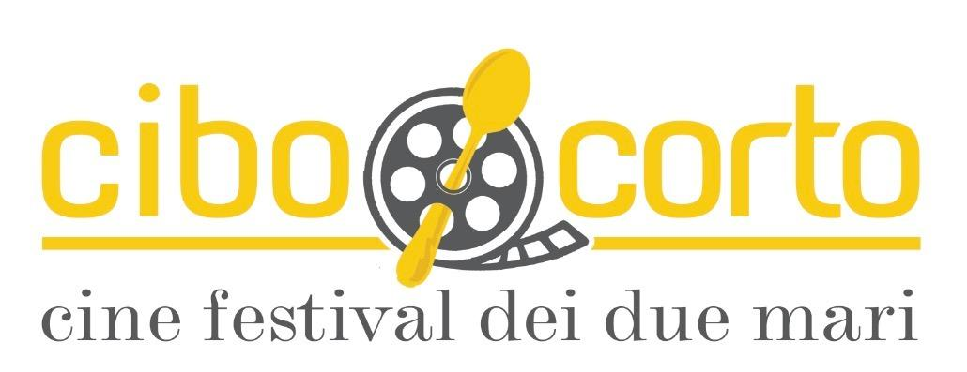

The Cultural Association "CAP 96010" is organizing the 1st edition of Cibo Corto Cine Festival of the Two Seas – Sicilian Food Film Festival, which will be held from 29th to 31st August 2019 in Portopalo di Capo Passero (Sr).

The Festival aims to contribute to the enhancement and dissemination, through video language, of history, culture, traditions and food and wine diversity of the territories to which it belongs.

The competition announcement is reserved for short films and animated films that will have food as a theme.

To reward the best works will be a jury composed of national and international experts in the film, communication and food and wine sectors.

The commission will select the works that will be projected during the event and those that will win the final prizes.
The trailers of all the works selected by the jury, based on technical, aesthetic and creative qualities, will be published on www.cibocorto.com

NOTICE OF COMPETITION AND REGULATION

Art 1. Place and date of execution

The first edition of CIBO CORTO CINE FESTIVAL DEI DUE MARI – Sicilia Food Film Festival will take place in Portopalo di Capo Passero (Sr) from 29th to 31st August 2019.

Art 2. Organization and theme of the competition

The audiovisual works in competition, of the following categories, must have as main theme the food that can be freely treated. The sections to which you can participate are short films and animated films divided into the following categories:

- Sicily category: for works produced and / or whose director comes from Sicily
- Mediterranean category: for works produced and / or whose director comes from a country overlooking the Mediterranean such as: Albania, Algeria, Bosnia and Herzegovina, Cyprus, Croatia, Egypt, France, Greece, Israel, Italy, Lebanon, Libya, Malta, Morocco, Monaco, Montenegro, Palestine, United Kingdom, Syria, Slovenia, Spain, Tunisia, Turkey.
- World Category: for works produced and / or whose director comes from a country other than the Mediterrean ones.

The jury reserves the right to change the category of membership by giving notice to the director and / or producer.

Art.3 Terms and conditions for registration:

1. Registration for the Festival is free
2. The works must not have been presented in the Italian commercial circuit, nor in the home video (Italian edition)
3. The unpublished and the national preview are considered preferential elements in the selection phase
4. Candidates must send an email to cibocorto@cibocorto.comindicating in the object the section of belonging (short film, animation).

For each work presented will serve:
- link to download the proposed work file or link for streaming viewing with relative password where present;
- link to download the movie trailer file or link to watch streaming with relative password where present;
- the entry form in word format (Annex A);
- Director's notes in word format
- Press complete with synopsis
- Audiovisual work sheet (Annex B)
- Disclaimer for the use of the work (Annex C)
- Processing of personal data (Annex D)

Art.4 Submission of the material

- All the above material must be sent by and no later than April 30th, 2019, to the e-mail cibocorto@cibocorto.com with the subject "Registration Competition CIBOCORTO CINE FESTIVAL" indicating the section of belonging, short films or animation, and indicating the reference category (World, Mediterranean or Sicily).
- Works that arrive after the indicated date will not be taken into consideration.

Art.5 Eligibility conditions for selection

- All short films and animation films (2D, 3D, stop-motion) submitted must have been completed after January 1st, 2015.
- The duration of the works must be not less than three minutes and not more than fifteen minutes (including head / tail titles - 10 seconds tolerance).
- The material sent will not be returned and will be stored in the archives of the Associazione CAP 96010 for the purposes of study, promotion or to be the subject of other reviews, in which case the Management will make arrangements with those entitled.

Art. 6 Selection of works

Of all the candidate works, short films and animation, will be selected in total:

- N. 10 for the “World” category
- N. 10 for the “Mediterranean” category
- N. 10 for the “Sicily” category

The finalist works for each category will be 3 and, for each category, they will compete for the Best Short Film of the Festival. The Festival Management will communicate the results of the selection by e-mail, to the address indicated by the members, by July 1st, 2019.

- All the finalist works will be screened on the days of the Festival and followed by a debate with the authors or a representative in office, if any.
- The Jury will have the discretion to accept works in the OUT OF COMPETITION section; they will be taken into consideration for a screening outside the competition.
- The awards "Best Short and Best Short Animation Short Food 2019" will be awarded during the final evening.
- The selected authors must then send by e-mail to cibocorto@cibocorto.com the link from which to download without fail by July 31st, 2019, under penalty of exclusion from the competition, a copy of the film to be shown during the festival in format: .mov or .m4v or .mpeg in order to carry out the technical tests. The Management reserves the right to request the replacement of copies that are inadequate to such a good public screening.

You will also need to send:

- 1 to 5 scene photographs in jpeg format of at least 2 Mega Pixels;
- 2 photographs of the director in the foreground in jpeg format of at least 2 Mega Pixels;
- Official poster of the film in jpeg format of at least 2 Mega Pixels.

Art. 8 Jury

1. The 2019 Festival Management will nominate a Jury composed of a jury president and four jurors. A representative of the 2019 Festival Directorate will attend the voting operations of the Jury jurors with exclusive assistance functions regarding regulation and practice.
2. The decisions of the Jury are indisputable and unappealable.

Art. 9. Awards

The jury will award the following prizes:

- Best Short and Best Animation - World Category
- Best short and best animation - Mediterranean category
- Best Short and Best Animation - Sicily Category
- Best short and best animation of the Cine Festival - the winners of the three categories will compete for this prize
- Best director
- Best Original Screenplay
- Best assembly
- Best photography
- Best lead actor
- Best protagonist actress
- Best Soundtrack
- Best special effects

Art. 10 Winners

The winning authors and producers commit themselves to mention the attribution of recognition in the titles of films and documentaries, in the title page of all the communication material and on all social media, none excluded.

Art. 11 Award ceremony

The award ceremony is scheduled for the evening of 31st August 2019.

Art. 12 Awards

The Awards will consist in the delivery of a plaque or craft work and in the maximum media coverage of the work by the organization.

Art. 13 Arbitrary clauses

1. Any controversy should arise between the participants and the organization must be devolved to the unquestionable determination of an arbitration board composed of three friendly referees composers, who will judge "ex bono et aequo" without procedural formalities, without prejudice to the adversarial nature of the parties , within 60 days of appointment.
2. Their determination will have the effect of agreement directly reached between the parties.
3. The arbitrators shall be appointed by each of the parties and the third by the first two or in default of agreement, by the president of the Court of Catania, who will also appoint the arbitrator for the party who failed to do so.

Art. 14 Final provisions

release
1. The authors and / or productions of the short films must authorize the screening of the works and their dissemination (on TV, press, radio, posters, internet, etc.), even partially, for the promotional purposes of the event.
2. To access any distribution channels of the work identified by the Organization, the member will be required to declare explicit consent. The denial of this consent is not detrimental to participation in the tender.
3. It is up to the Organization to select some short films for screening in other national or international festivals.

Obligations of members

1. The subscriber accepts in its entirety and without conditions the present Rules. Any irregularity or non-fulfillment will make the participation in the competition null and void. Upon registration, the subscriber must also sign the information for the processing of personal data (Annex D).
2. The member is responsible for the content of the works presented, for any third party copyrights and in particular for the privacy rights of the subjects involved in the proposed artistic works.
3. The member assumes responsibility for the truthfulness of the information indicated.
4. The member answers for any violations of copyright or privacy.
6. The intellectual property of the works and the consequent rights remain with the authors.
7. The author guarantees to be unique and exclusive creator and creator of the works submitted.
8. The author and / or producer, in accordance with the established rules on copyright, ensures that the work in competition is exempt from any right of artistic property or rights that may belong to third parties and undertakes to protect the organizers against any action that could be exercised against them by those entitled. Furthermore, for scenes that portray people and / or things for which specific consent is required, the author and / or producer declares that he has obtained the necessary consent (also, where due, pursuant to Legislative Decree n. 196/2003, "Code regarding the protection of personal data") for participation in the present competition and for the conferment to the organization of the rights referred to in these Regulations.

Art. 15 Privacy

The information stored in our archive will be used for participation in the competition and for sending information material for promotional purposes related to the festival. It is possible to request correction or cancellation, as required by law 675/96 on the protection of personal data.

Art. 16 Final indications

- For reasons of force majeure, for technical-organizational problems, to make improvements or in case of unforeseen exceptions, the organization may modify the present Rules communicating the information on the site of the event.
- The organization also reserves the right to cancel the event if unexpected events occur, organizational difficulties and / or adverse weather conditions.
- Although not explicitly stated, the organization of the competition is authorized to decide independently.
- The present competition announcement and the participation form are published on the website: http://www.cibocorto.com
- This regulation is written in Italian and in English. In case of interpretative contrast, the Italian version is valid.

For any clarifications and / or further information write to: info@cibocorto.com

