Cinema dal Basso presents:
Open call for submission of video art works for “String”
Refugee Festival Scotland
(June 14-26 2016)
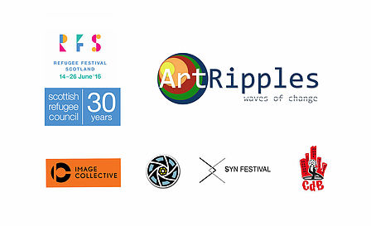

Conditions of participation
- The content of the works must be related to the theme of the migrants
- Except for the proposed theme, the call is open to any kind of works, with no limitations on genre, narrative formula and length.
- All the works must be subtitled in English and, preferably, in Italian.
- The works must be sent by wetransfer, dropbox, vimeo or as attached files to cinemadalbasso@gmail.com

Terms of participation
The materials must arrive no later than June 7th, 2016 at 5:00pm.

Selections
The works of art will be admitted at the Festival according to the quantity and quality of the work received.
The selection board reserves the right not to admit at the Festival (and consequently at the selection) any work that, even respecting the conditions of participation, isn’t considered compatible with the main idea of the Festival.
The finalists will be presented by Cinema dal Basso as part of the Refugee Festival Scotland during different soirees of the “Strings” exhibition, which will take place at Ocean Terminal of Edinburgh from the 17th to the 24th of June 2016

Participation at the Festival
The participation at the Festival is free.

Events
The program of the Refugee Festival Scotland and of the related events, as well as any eventual variation, will be published on Scottish Refugee Council web site and on the Facebook pages of Refugee Festival Scotland, Cinema dal Basso e ArtRipples Collective.

Acceptance of the rules
Enrolling and participating at the Festival and at the selection means that you must totally accept the following rules and approval of the use and reproduction, by Cinema dal Basso, of the works and their video or photo abstracts for no matter what kind of documentative or promotional publication.
Sending the video materials to take part to the Festival implies that you authorize the organization to show the works of art entirely for cultural and promotional purposes.
The authors and/or the producers of the works free Cinema dal Basso from the covering of the rights on their films.
The works of art won’t be given back but they will be part of the archive of Cinema dal Basso, who reserves himself the right to show them, prior communication to the author, even outside the Festival contest, using them as part of their activity and their projects.
Each exception eluding the present regulation, will be faced by the direction according to its will.

Subscription

The competition announcement, the registration form and the forms enclosed can be downloaded from the Web site: www.cinemadalbasso.wordpress.com.
To be selected you must send by e-mail:
- The registration form, accurately filled in and signed.
- A copy of your own work (as at the point 4 of the “Condition of participation”).
- A short synopsis of the work.
- At least one frame or the cover of the works in league in high resolution.
The materials accurately signed and filled, must be sent by e-mail to: cinemadalbasso@gmail.com
All the participants will be warned, by e-mail, when the materials will be received so as they’ll get the confirmation they are properly subscribed to the contest. They’ll also be warned, by e-mail, only about the admission at the final phase.

