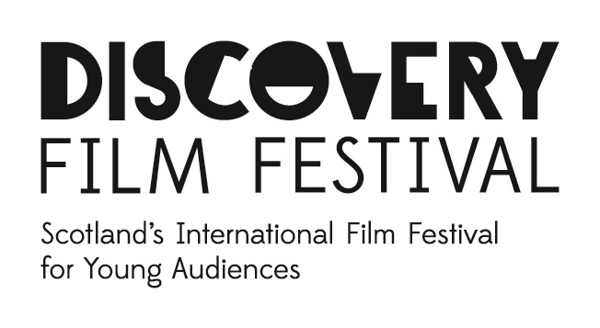

DISCOVERY FILM FESTIVAL 2016

www.discoveryfilmfestival.org.uk

This year’s festival will be the 13th edition, running from Saturday 22nd October to Sunday 6th November 2016.

The festival offers the best in contemporary world cinema for children and young people, from the age of three upwards, both features and shorts.

We are particularly interested in short animations of up to ten minutes in length that will engage and speak directly to a young audience. Language-free is our preference, though films subtitled in English will also be considered.

The festival is non-competitive.

The festival works with both schools and the general public. Our schools programme offers specially designed educational resource materials for pre- and post-screening activities in the classroom (see examples at www.discoveryfilmfestival.org.uk/resources), and our public programme will create practical creative workshops to accompany key titles in the festival. Our festival is therefore very much created for its audiences, rather than having an industry focus.

In terms of this year’s festival, our programming is an already started and ongoing process so submissions can be made immediately. Our programme is finalized in early July, so we have a submission deadline of Sunday 3rd July 2016 for this year’s selection.

Direct contact, including questions and requests for clarification, can be made to Mike Tait, Festival Producer, via mike.tait@dca.org.uk.

