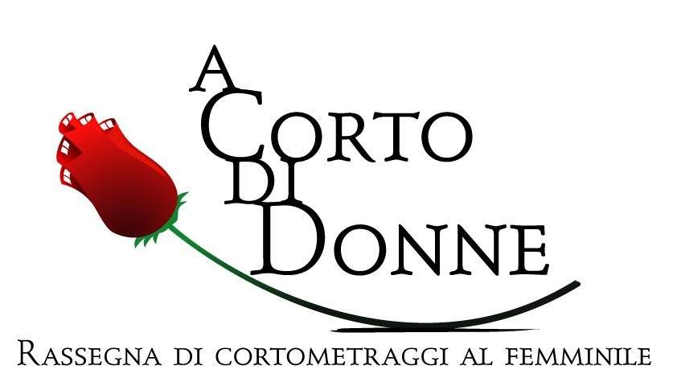

9th edition
Pozzuoli (Naples) – ITALY
14 > 17 July 2016

REGULATIONS

INTRODUCTION

1 The ninth edition of “A Corto di Donne”, women’s short film festival, will be held in Pozzuoli (Naples) from 14 to 17 July 2016.

2 “A Corto di Donne” supports the creativity of women, offering a place of confrontation to those filmmakers from all over the world who have chosen to express an original point of view on society, feelings and issues of our time, by means of an innovative cinematographic language.

REQUIREMENTS

3 Only short films exclusively directed by women are eligible for the festival.
4 Subject is free. Accepted genres are: Fiction, Documentary, Animation, Experimental.

5 Maximum length allowed is 30 minutes.

6 Shorts must have been completed after January 1st 2014.

REGISTRATION

7 Through the official website of the festival – www.acortodidonne.it – it is possible to download the entry form. Further information can be obtained by sending an email to info@acortodidonne.it or by calling the telephone number (+39) 347.6675.785.

8 Works must be sent on DVD, along with the filled entry form, to the following address:
“A Corto di Donne” – c/o Azienda Autonoma Cura, Soggiorno e Turismo – Piazza Matteotti, 1 – 80078 Pozzuoli (NA) – Italy.

9 As an alternative to traditional postal service, films can be registered through the online submission platforms accessible via the festival’s website, or a secure link for streaming preview and download of the short film can be provided via e-mail at info@acortodidonne.it. Only downloadable links are accepted.

10 Deadline: 15 April 2016.

11 Registration is free.

12 All materials sent from outside the European Union must contain the following mention on the envelope: "SENZA VALORE COMMERCIALE, SOLO PER FINI CULTURALI / NO COMMERCIAL VALUE, FOR CULTURAL PURPOSES ONLY".
13 It is possible to submit more than one film, including each of them on a different DVD.

14 Short films submitted must be provided with English subtitles, unless they are already spoken in English. The insert of English subtitles is a must also for Italian short films selected for the final step of the festival.

AWARDS

15 The selected juries of the festival, composed of professional representatives from film and cultural industry, will award a prize to the best short of each category: Fiction, Documentary, Animation, Experimental.

16 A special award will be allocated by the festival’s directors to the best Italian short, to be chosen between all the Italian films selected for the competition.

17 A special “Young Jury” award will be assigned, by a selected number of high school students from the Phlegraean Fields, to the best short film for each section of the festival.

18 Juries’ decisions are undisputable.

ARRANGEMENTS

19 The Festival’s directors will choose the films to be screened, and this decision is undisputable.

20 It is left to the organizers the possibility of establishing other sections of the festival, where to screen those interesting short films that have not been selected for the competition, but which deserve the attention of the audience.
21 Submitted films – even those ones which have not been selected – will not be sent back in any case and will become part of the film archive of the organizers. They could be used, only for cultural or educational purposes, even after the carrying out of the event, in exchange with other institutions or associations, to promote the festival in Italy and abroad.

22 The organising body of the festival will take due care of the copies of the works submitted, but assumes no responsibility for possible damages during transportation or at the Festival venues.
23 The author or the producer will be responsible for the content of the work and for the diffusion of materials protected by copyright.

24 Any customs duty expenses will not be paid by the festival.

25 In case of interpretation problems with this document translated into other languages, the Italian version will stand as proof.
26 Participating in the competition implies acceptance of the Regulations. The Festival’s direction reserves the right to decide on unforeseen cases.

