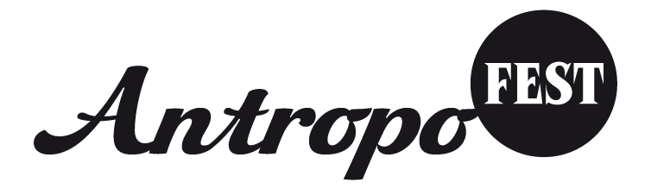
Application form
entering a film in Antropofest 2016

Prague, 29th January – 30th January 2016

Original name of the film
_____________________________________________________________________
Name of the film in English
_____________________________________________________________________

Length ____________________________ Format _________________________

Language of dialogues________________________________________________
Language of subtitles_________________________________________________

Country and year of production________________________________________

Synopsis__________________________________________________________________________________________________________________________________________________________________________________________________________________________________________________________________________________________________________________________________________________________________________________________________________________________________________________________________________________________________________________________________________________________________________________________________________________________________________________________________________________________________________

Director_____________________________________________________________
Contact (e-mail, telephone number, address) __________________________________________________________________________________________________________________________________________
Brief biography ____________________________________________________________________________________________________________________________________________________________________________________________________________________________________________________________________________________

Production___________________________________________________________
Contact (e-mail, telephone number, address) __________________________________________________________________________________________________________________________________________

Camera______________________________________________________________
Script______________________________________________________________
Edit________________________________________________________________

Launching of film, awards _______________________________________________________________________________________________________________________________________________________________________________________________________________

Applicant (name)____________________________________________________
Contact (e-mail, telephone number, address) __________________________________________________________________________________________________________________________________________

Send the application form together with the film on DVD. We accept either classical DVD VIDEO (PAL) or MOV/MP4 (codec H264, SD or HD resolution). Additional subtitles (not only burned in the image) are also required - we need it for translation to Czech. We accept only subtitles with exact timing in srt format (created by Subtitle Workshop or other software). We all also need photographs from the film in printing quality by November 17th 2015 together with the movie to the address Antropofest, P.O. BOX 56, 253 01, Hostivice, Czech Republic. Designate the envelope clearly with the word „Antropofest“. You can also send the photographs from the film by e-mail to info@antropofest.cz or you can put the photo and movie to some cloud (as Vimeo, WeTransfer etc) and send us the link.

By entering your film you agree to the following conditions:
- Relevance to the given anthropological themes will be taken into account when choosing the film. Attention will also be paid to the content and artistic quality of the film.
- Films of any length will be accepted.
- By entering his/her film, the owner of the rights gives consent to the film being projected at Antropofest events and archived for the purposes of the civil association Antropofest.
- There is no entering fee and no financial reward to applicant or director of the movie.
- Sent DVDs are not returned.
- Photographs and information from the application will be used for the purposes of the festival, included in the festival programme/catalogue and posted on the Antropofest website.
- The deadline for applications is November 17th 2015. Films which arrive after this date will not be included in the projection of the topical year of the festival.
- Applicants will be informed about their film being incorporated into the festival programme via e-mail and not later than 20 days before the beginning of the festival.
- Expenses connected to transporting the film to the address Antropofest, P.O. BOX, 56, 253 01 Hostivice, Czech Republic will be covered by the applicant.

Name of applicant

_________________________________________________________________

Date, Place_______________________________________________________

Signature ________________________________________________________

