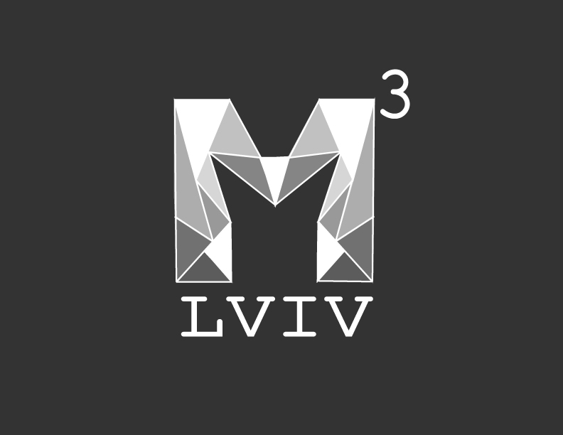
M³ LVIV Festival – Short film Regulations
All the movies should be no older than 2012 year of production;
The duration of each short film should be no longer than 20 minutes;
All right are reserved, each movie will be shown only once during the Festival and will not be uploaded online.
Submission will be accepted via: http://www.clickforfestivals.com/media-art-lviv-festival

