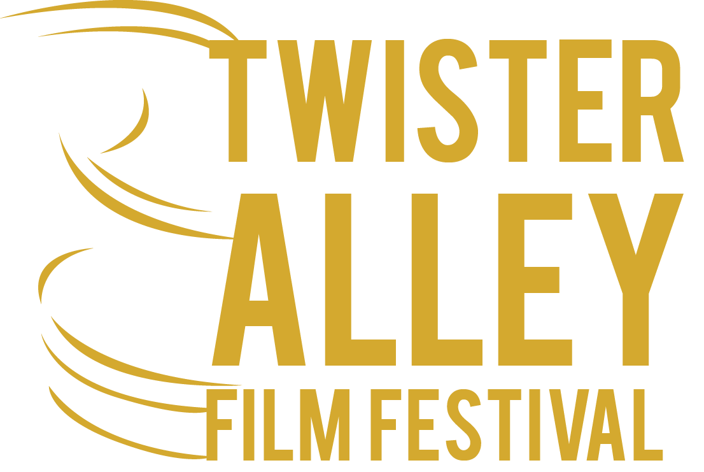

OFFICIAL RULES

Films of all lengths (short & feature) and all genres (family, animated, comedy, drama, sci-fi, action, horror, documentary, foreign) are welcome to submit.

Screenplays (both short & feature) of all genres are welcome to submit. Screenplays must be unproduced as of the date of the film festival.

Awards will be given for both feature and short film categories including Best of Fest, Best Comedy, Best Drama, Best Midnight (Sci-Fi, Action, Horror), Best Animated/Family, Best Actor/Actress, Best Supporting Actor/Actress, Best Editing, Best Sound Design, Best Cinematography, Best Art Direction, Best Festival Screenplay, Best Contest Screenplay, Next Gen, and Best Movie poster.

Submissions accepted via: http://www.clickforfestivals.com/twister-alley-film-festival

Twister Alley Film Festival
Attn: Josh Hope
12404 Village Lane
Oklahoma City, OK 73170

DEADLINES
Early deadline: 12/31/15, Feature $25, Short $20,
Regular deadline: 2/29/16, Feature $30, Short $25,
Late deadline: 3/31/16, Feature, $40, Short $35,

