14th New Media Film Festival®

June 7th – June 8th 2023-Hybrid

Los Angeles

SOMETHING FOR EVERYONE: NEW MEDIA FILM FESTIVAL®
A Hollywood hit! The annual New Media Film Festival® offers a refreshing approach to the discovery and recognition of diverse new media content.

This isn’t the traditional clear-cut Hollywood film festival, and that’s exactly how they want it to be. Welcome to a film festival made by creatives, for creatives. This is a place where the works of all ages, all cultures and the use of all media are celebrated. 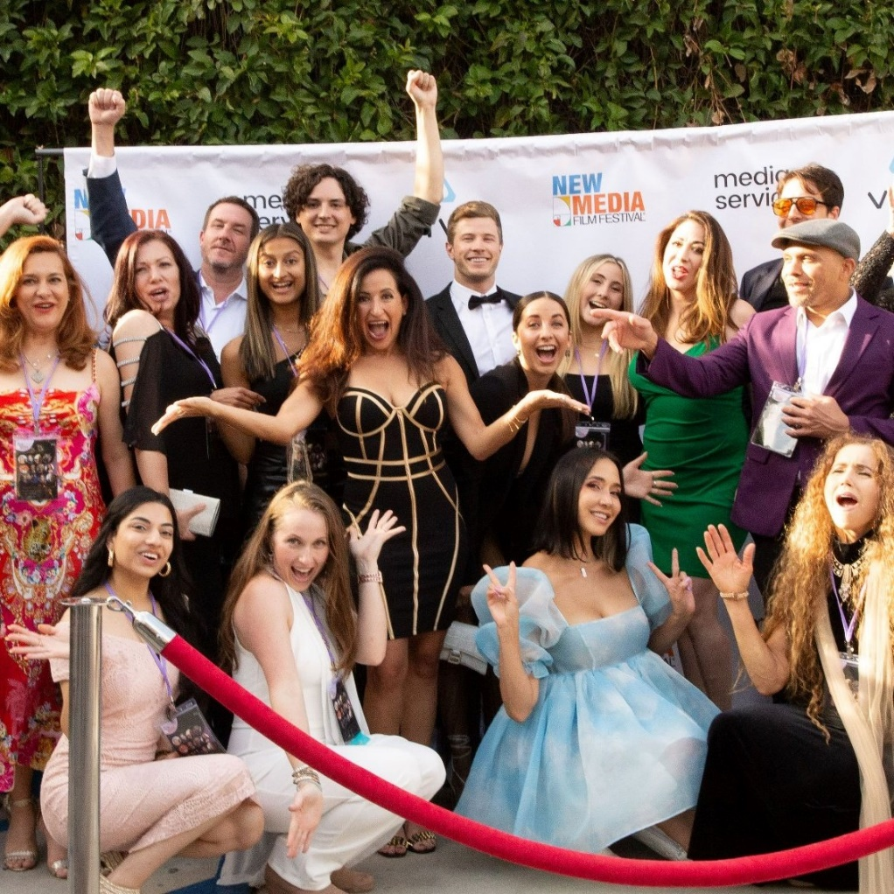
Photo: Fatima Hurd
28 Classic & Technology categories vie for $45,000 in Awards

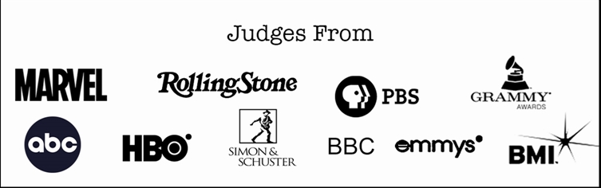

Over 1000 titles have received distribution offers. AMC, Netflix, PBS, Amazon, Tubi, WB, FilmRise & ROKU are just a few of the companies that have met with our content creators.

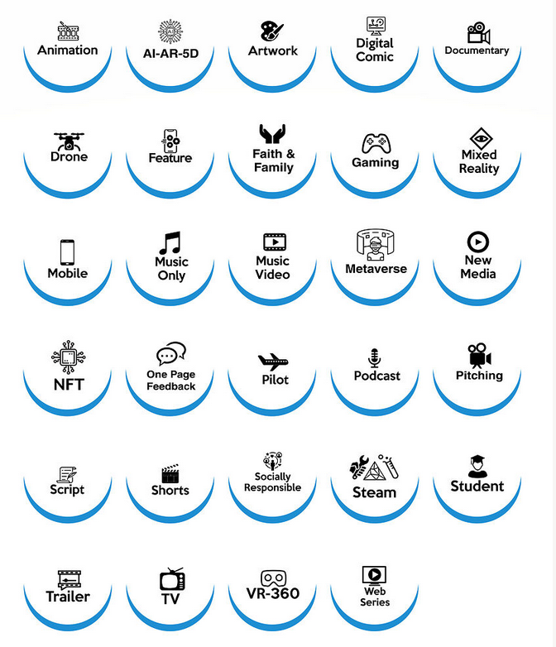
New Media Film Festival® is an official IMDB Event and UFFO accredited festival. Known as an infinite catalyst for story and technology and the 1st major festival in innovation, story & mediums. This festival creates access to deal makers, creatives & talent. Several projects have been funded by connections made at the festival as well as many business connections. The Red-Carpet Press Junket, VIP Soiree, Screenings with Q & A, Awards, Networking and International Art Exhibit make this a must attend event.

History
In 2009 New Media Film Festival® was announced in Second Life at Los Angeles Studios as an annual story and technology event, honoring stories worth telling. The festival brings together the work of established and emerging New Media Content Creators and video artists, from the US as well as internationally. A multiple Award-Winning Festival with a student custom career goals program and a we give back program.

The rationale behind the festival is clear. New Media Film Festival® continues to show its lasting power and potential to evolve – there is scope for truly groundbreaking and compelling work in the world of storytelling. The festival is designed to both discover and cultivate highly creative work from emerging and seasoned content creators.

Testimonials
“Very well-run festival. Beautifully international in scope. Thank you for spotlighting all kinds of emerging media!” – Emmy Winner Dustin Morrow

“Best Vibe Ever, Beyond Expectations” – Financial Capitol

“In the world of festivals, it is refreshing that there are no politics or pay to play at New Media Film Festival® and it is run by a team of caring and passionate people that put the creators first and respects the content, not the profits.”
– Angelwood Films

Contact – crystal@newmediafilmfestival.com www.newmediafilmfestival.com
2355 Westwood Blvd. 381 Los Angeles CA 90064 USA 310-288-1100

# # #

