Melbourne World International Film Festival®, November 20-30, 2015.
The Melbourne World International Film Festival is a global Industry event held at one time in the world biggest cities: Melbourne, New York City, Los Angeles, Toronto, London, Hong Kong, Singapore - that will reach out to the many filmmakers who like to place films at the centre of the acts as a truly international film industry event, a great place for business on movie or script.
FILM CATEGORIES 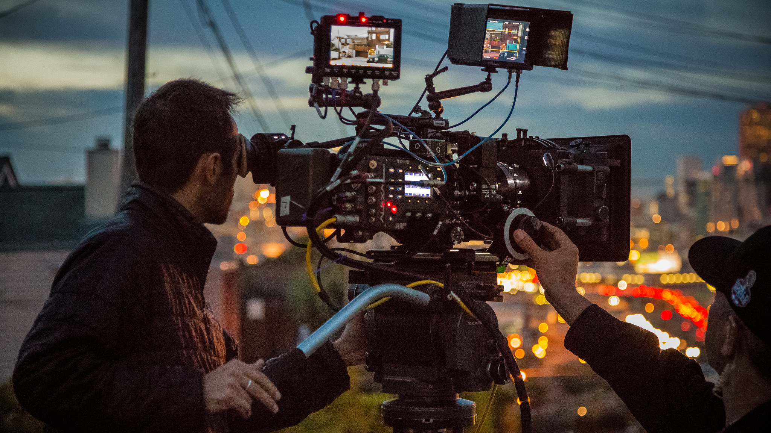
Short (Online link)
Any film Less than 60 mins.
Narrative Feature (Online link)
Any Film Over 60 mins.
Documentary (Feature) (Online link)
Documentary is a nonfictional motion picture intended to document some aspect of reality, primarily for the purposes of instruction or maintaining a historical record. Documentary is a broad category of visual expression that is based on the attempt, in one fashion or another, to document reality: a creative work of non-fiction, intended for cinema or TV release. Any Documentary Film over 60 mins will be considered in this category.
Animation (Feature) (Online link)
Any type of film that is animated and over 60 mins, will be accepted into this category.
Music (Feature) (Online link)
Music is an art form, entertainment, or activity which involves organized sound and varies according to culture. Any film that makes use of music, in its creation, performance, significance and even its definition, will be considered in this category.
Foreign Language (Feature) (Online link)
Any film in a language other than English.
Documentary (Short) (Online link)
Any Documentary Film under 60 mins will be considered in this category.
Animation (Short) (Online link)
Any type of film that is animated and under 60 mins will be accepted into this category.
Foreign Language (Short) (Online link)
Any short film in a language other than English.
Music (Short) (Online link)
Experimental (Online link)
Experimental is an artistic practice relieving both of visual arts and cinema.
Feature Script (Online link)
Any script over 130 pages, supply please on a pdf
Short Script (Online link)
Any Script under 120 pages, (Online link)
Best Television series Drama (Online link)
Best Television Comedy Series (Online link)
Best Television Mini Series (Online link)
Best Television Documentary (Online link)
Best Television drama not of the English Language (Online link)
Use this categories for submitting online previews for consideration.
SECTIONS
The Melbourne World International Film Festival will include the following sections:
World Competition
American Cinema
European Cinema
Cinema of Asia, Africa and Australia
Documentaries of the World
Animation sector
Children and Student Cinema
INTERNATIONAL LOCATIONS
New York City
Los Angeles
Toronto
London
Hong Kong
Singapore
Melbourne

MISSION & OBJECTIVE
Melbourne World International Film Festival main objective is to provide the opportunity for the filmmakers from all over the world to showcase their films in a welcoming environment, as well as to give local filmmakers a platform to network amongst industry professionals and fellow cinematic artists. Melbourne World International Film Festival is looking forward to fostering these relationships and helping filmmakers get their projects seen by larger audiences. Film Festival unites world educational, cultural and film organizations in a celebration of world filmmaking.

Exceptional professional network of industry professionals look at all films entered and give business and commercial advice, the distributors attending make offers to the filmmakers for their works to put together the movies in the world marketplace. The amount of platforms and festivals offered to the filmmakers are unique, all this create a ripple for your movie to be seen around the world.

The Melbourne World International Film Festival is like no other International film Festival, it put you the filmmaker in front of potential investors and different parts of the World at one time. The Film Festival put your movie in front of the world potential distribution and sales to look at the possibility of offering you real deals and real help for you the filmmaker, look at our program read the short bios of the professional attending. The Melbourne World International Film Festival is dedicated to showcasing new and innovative films while fostering the next generation of filmmakers. The festival provides platforms to introduce their films to the broadest possible audience. We are a strong advocate on social change issues.

The Film Festival creates experiences that bring people together to discover extraordinary films from around the world and give voice to filmmakers in Global World. The goal of the Melbourne World International Film Festival is to encourage cultural diversity and understanding between nations, to foster the cinema of all continents by stimulating the development of quality cinema, to promote filmmakers and innovative works, to discover and encourage new talents, and to promote meetings between cinema professionals from around the world.

Committed to celebrating, promoting and developing film industry to showcasing the best films from around the world, Melbourne World International Film Festival produces one of World's leading film festivals and plays a leadership role in offering project development programs for international filmmakers both within and beyond different countries and borders.

ABOUT THE FESTIVAL

The Melbourne World International Film Festival will culminate in a glamorous red carpet awards ceremony recognising unrivalled ideas, productions and film concepts. The prestige's filmmaker awards are presented to the finest films entered, named as a highly prized industry awards that recognises those willing to make those final steps to reach the peak of their profession. The Melbourne World International Film Festival is a global platform for you to network, discover future trends and achieve commercial success on a worldwide level.
Over 10 days this unique one-stop transnational media community gives you the chance to network and do business with other like-minded creative filmmakers and their representatives from around the globe.
Melbourne World International Film Festival is a festival of juried films, seminars, panels, special events and parties. It's a collaborative, global multi-week, annual cultural event designed to celebrate the creativity and hard work of filmmakers from around the world! A mix of local, national and international award winning films are screened over biggest world cultural places.

Melbourne World International Film Festival is dedicated to showcasing the spirit, passion and skills of bona fide filmmakers from around the world to the audience in America, Europe, South East Asia and Australia.

​With the help of digital media technology and crowdfunding, it is now getting easier for anyone to just take up a camera and make a film. The most important ingredients in the mix is finding your own voice, the creative ideas and mastering the skills necessary to make a captivating experience. However, with the increasing number of works being produced and the reshaping of cinema and major film festivals, it is now much harder to connect a live audience to non-mainstream arthouse films.
It is the conviction of the Melbourne World International Film Festival team that filmmakers who put their heart and soul to tell a story should have the chance to show their works to a crowd, even if the budget is small or no recognizable name is involved.
We are also including and actively supporting not only industry classic films, but works that are experimental, breaking ground with forms of narrative and crossovering into video arts.

All films will be reviewed as they are submitted and the best of each category will be chosen to screen at the festival. A jury of industry professionals will then view the finalists and choose winners.
Filmmakers planning on attending should notify Film Festival as soon as possible, so their names may be listed in the scheduled program with their film to be in attendance.
A substantial number of accredited national and international press, TV and film buyers and distributors also participate.
Final jurors for Melbourne World International Film Festival will come from a selection of industry professionals in filmmaking, distribution, film media, and festival programmers from Sundance, AFI Silverdocs, Slamdance, SXSW and more.

Melbourne World International Film Festival is the longest running and largest film festival in the World.
The Melbourne World International Film Festival attracts worldwide distributors and offers immediate distribution through our channels after the festival of all selected projects. Get your movie out on iTunes, Netflix, Amazon and many other venues after the Film Festival.
In cooperation with many great and uniquely experienced partners we will offer a high quality festival with a unique charm. Great thanks to the best film schools and institutes which helped us.

The Melbourne World International Film Festival is presented each year from November, 20 to November, 30, 2015. It is one of the the largest film festivals in the world, with more than 1200 features, documentaries and short films to an audience of over 500,000 each year. Film Festival is consistently ranked as one of the top festivals in the World.

Third world countries, also known as emerging or developing nations, today have produced more than half of the world’s films.
Unfortunately, a majority of their filmmakers have stayed relatively unknown as western films continued to dominate the film market. But with perseverance and ingenuity, they are finally beginning to get the recognition they deserve. The Melbourne World International Film Festival provides these filmmakers platforms to not only be recognized but also actively participate in a level playing ground with filmmakers from developed nations and bring their work to a global audience.

A new age in cinema will rise through films the audience has long waited for: an exhilarating experience of foreign cultures and worlds they have never seen, films that, perhaps, will forever change the industry and society.

COMMITMENT TO EDUCATION

Unlike many festivals around the country, Melbourne World International Film Festival has dedicated itself to making a difference in the lives of different people by helping to fulfill their dreams in the world of film. Over $2.3 million has been donated over the years to provide new technologies for optimal learning in the form of grants and scholarships. Past activities have included seminars, workshops, and "hands-on" experience with filmmakers and professionals from all areas of the industry. The climax of student activities is the Student showcase of films, held during the annual film festival. Here, these young artists are the focus. Student filmmakers from high school, community college, and university levels enter their work in competition for scholarship money and the chance to have their film shown on the "big screen" during the festival.

SELECTION PROCESS

All films are pre-screened by the festival programmer and Film Festival Screening Committee, using a score sheet that assesses technique, execution, material and originality. High scoring films are moved into the programming and Jury process which involves re-screenings and re-scorings.

PROGRAMMING

The festival is programmed by thematic blocks, grouping complimentary films together to maximize audience appeal and to create a specific experience. Each block has a host who introduces the films and filmmakers.

GENERAL RULES

Submission Guidelines:
Melbourne World International Film Festival prefers online teasers, trailers, music and screeners for preview purposes. Entries should be submitted by secure password-protected internet link made on: Youtube.com or Vimeo.com. The link must not be visible to the public.
Works in progress will not be considered for competition or screened at Film Festival. All entries must be properly uploaded and received by Film Festival on or before 12:00 (midnight), November 7, 2015. Press kit must be submitted to the Melbourne World International Film Festival via email: info@worldinternationalfilmfestival.com
The filmmaker(s) must secure all rights, licenses, clearances and releases necessary for exhibition. Work may originate in any film, video or digital medium. All footage must be original. The music may be original or an interpretation. You must certify receipt of any and/or all releases and/or permissions.

SUBMISSION GUIDE

Entries may be only entered as an on-line screener.
Foreign language work must be dubbed or subtitled in English. Please do not send any paper press kits or any other print materials or DVD's until they are requested by the festival.
All entry materials become the property of the Melbourne World International Film Festival and will not be returned. No refunds. Entries will not be returned.
After you submit your work for review on-line, the link must not expire until after you are notified of the jury panel's selections.
Press kit, Screenplays must be submitted in English.

DEADLINES AND FEES:

World International Film Festival locations:
New York City, Los Angeles, Toronto, London, Hong Kong, Singapore, Melbourne.
Opening Date February 1, 2015 - Submission fee: free entry.
August 24, 2015 - Earlybird Deadline: 99$ Submission fee for all 7 film festivals.
August 31, 2015 - July Deadline: 149$ Submission fee for all 7 film festivals.
September 7, 2015 - August Deadline: 199$ Submission fee for all 7 film festivals.
October 1, 2015 - September Deadline: 249$ Submission fee for all 7 film festivals.
October 8, 2015 - Regular Deadline: 299$ Submission fee for all 7 film festivals.
October 22, 2015 - Late Deadline: 349$ Submission fee for all 7 film festivals.
November 5, 2015 Decision Deadline: 399$ Submission fee for all 7 film festivals.
Submissions must be received online before: November 6, 2015
SUBMIT you Film to 7 locations by the price of One now.
SELECTION & NOTIFICATION GUIDE

If you are selected we will post it on our website and notify you by email. If selected we prefer a downloadable file.
We will notify you if you are not accepted as well.

Press Kit Via Online – submissions that included an online press kit
Press Kit Via Mail – submissions that will submit a press kit by mail
Submission Copy Via Online (Films) – film submissions that chose the Secure Online Screener Submission option, regardless of whether they have uploaded their Screener
Submission Copy Via Online (Scripts) – script submissions that are or will be submitted electronically via Withoutabox
Submission Copy Via Mail – projects that will be submitting a submission copy via mail

The Screenplays and Press Kits must be submitted in the following file formats:
The file formats you can choose from include Microsoft Word (.doc), PDF (.pdf), Final Draft (.fdr, .fdx, .fds), Rich Text (.rtf), Plain Text (.txt).
The trailer (teaser), screener must be submitted in the following file formats: HD [1008p]

AWARDS

The Melbourne World International Film Festival presents over $30,000 in cash awards to filmmakers in competition, as determined by the awards jury.
WINNERS:
ONE (1) OVERALL GRAND JURY WINNER
ONE (1) OVERALL AUDIENCE AWARD WINNER
ONE IN EACH CATEGORY (5) NARRATIVE CATEGORY WINNER
ONE (1) DOCUMENTARY CATEGORY WINNER
ONE (1) DOCUMENTARY (SHORT) CATEGORY WINNER
ONE (1) EXPERIMENTAL CATEGORY WINNER
ONE (1) SHORT FILM WINNER
BEST DIRECTOR (1) OVERALL GRAND JURY WINNER
BEST ACTRESS (1) OVERALL GRAND JURY WINNER
BEST ACTOR (1) OVERALL GRAND JURY WINNER
BEST SCREENPLAY (1) OVERALL GRAND JURY WINNER
BEST ARTISTIC CONTRIBUTION (1) OVERALL GRAND JURY WINNER
INNOVATION AWARD (1) OVERALL GRAND JURY WINNER

All (17) winners will be awarded with the Melbourne World International Film Festival AWARD and cash prizes.
Awards for BEST in each category.

RETURN OF MATERIALS

We will not return screener materials.
The Melbourne World International Film Festival does not give waivers or discounts.
The Melbourne World International Film Festival does not pay any rental fees for submitted work.
The individual or corporation submitting the film hereby warrants that it is authorized to commit the film for screening, and understands and accepts these requirements and regulations.

LOSS & DAMAGE

Every precaution will be taken to safeguard films, videos and publicity materials while they are in the possession of Melbourne World International Film Festival. However, if loss or damage occurs, Film Festival cannot accept or assume responsibility.

OTHER REQUIREMENTS:

All non-English films must have English subtitles.
Only online submission for one film is accepted.

WINNER SELECTION:

All films will be reviewed as they are submitted and the best of each category will be chosen to screen at the festival. A jury of industry professionals will then view the finalists and choose winners. The judges panel will consist of multiple industry professionals including (but not limited to) HBO producers, Univision directors, local established filmmakers, and more.
- See more at: http://melbourne.worldinternationalfilmfestival.com/about#sthash.AeZtBUPB.dpuf

